**SQL SERVER – 2005 – Difference Between INTERSECT and INNER JOIN – INTERSECT vs. INNER JOIN**

INTERSECT operator in SQL Server 2005 is used to retrieve the common records from both the left and the right query of the Intersect Operator. INTERSECT operator returns almost same results as INNER JOIN clause many times.

When using INTERSECT operator the number and the order of the columns must be the same in all queries as well data type must be compatible.

Let us see understand how INTERSECT and INNER JOIN are related.We will be using AdventureWorks database to demonstrate our example.

***Example 1: Simple Example of INTERSECT***

SELECT *  
FROM HumanResources.EmployeeDepartmentHistory  
WHERE EmployeeID IN (1,2,3)  
INTERSECT  
SELECT *  
FROM HumanResources.EmployeeDepartmentHistory  
WHERE EmployeeID IN (3,2,5)

*ResultSet:*

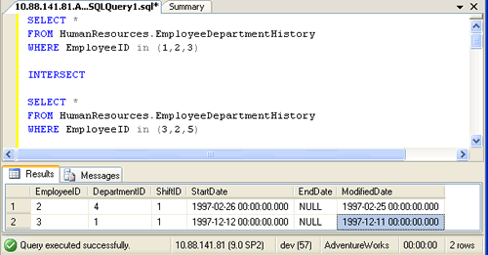

*Explanation:*  
The ResultSet shows the EmployeeID which are common in both the Queries, i.e 2 and 3.

***Example 2: Using simple INTERSECTbetween two tables.***

SELECT VendorID,ModifiedDate  
FROM Purchasing.VendorContact  
INTERSECT  
SELECT VendorID,ModifiedDate  
FROM Purchasing.VendorAddress

*ResultSet:*

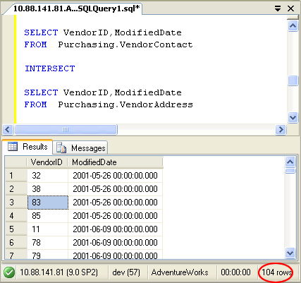  
 *Explanation:*  
The Resultset shows the records that are common in both the tables. It shows 104 common records between the tables.

***Example 3: Using INNER JOIN.***

SELECT va.VendorID,va.ModifiedDate  
FROM Purchasing.VendorContact vc  
INNER JOIN Purchasing.VendorAddress va ON vc.VendorID = va.VendorID  
AND vc.ModifiedDate = va.ModifiedDate

*ResultSet:*

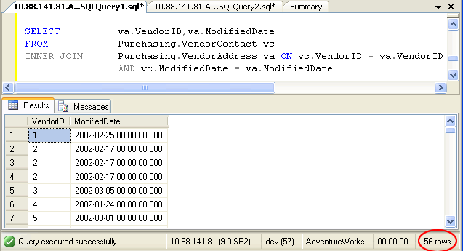

*Exlanation :*  
The resultset displays all the records which are common to both the tables. Additionally in example above INNER JOIN retrieves all the records from the left table and all the records from the right table. Carefully observing we can notice many of the records as duplicate records. When INNER JOIN is used it gives us duplicate records, but that is not in the case of INTERSECT operator.

***Example 4: Using INNER JOIN with Distinct.***

SELECT DISTINCT va.VendorID,va.ModifiedDate  
FROM Purchasing.VendorContact vc  
INNER JOIN Purchasing.VendorAddress va ON vc.VendorID = va.VendorID  
AND vc.ModifiedDate = va.ModifiedDate

*ResultSet:*

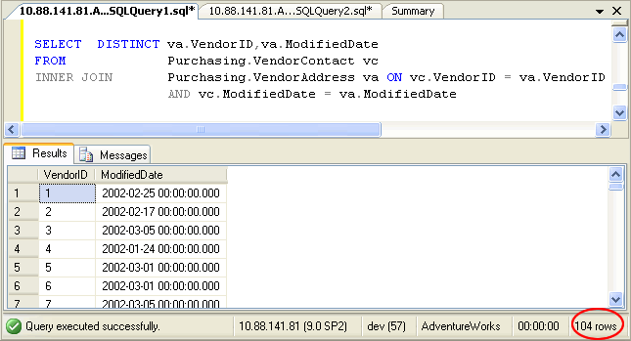

*Explanation:*  
The resultset in this example does not contain any duplicate records as DISTINCT clause is used in SELECT statement. DISTINCT removes the duplicate rows and final result in this example is exactly same as example 2 described above. In this way, INNER JOIN can simulate with INTERSECT when used with DISTINCT.

Summary :

**INNER JOIN can simulate with INTERSECT when used with DISTINCT.**